BSCNRN101924
BSCNRB131924
BSCNRB519425
OSEMBO MORDECAI
SYSTEM DESIGN DOCUMENT
Design of a Scholarship Finder Web Crawler

1. Introduction
The Scholarship Finder Web Crawler and Search Engine is a web based information retrieval system designed to automatically collect scholarship information from trusted scholarship websites. The system crawls selected websites, extracts relevant scholarship details, stores them in a centralized database and allows users to search for scholarship opportunities through an easy to use interface. This is because information about scholarships is scattered across thousands of independent websites university financial aid portals, government education ministries, NGOs, and private foundations each with its own layout, terminology and update schedule. There is no reliable filterable place an aspiring student can search to find scholarships they are actually eligible for.
The purpose of this system is to reduce the time students spend searching multiple websites for scholarship opportunities by providing one centralized search platform. It focuses only on scholarship related information. It will crawl selected scholarship websites, collect scholarship details, remove duplicate pages, store collected data, allow users to search scholarships and allow administrators to manage the crawler.
The objectives of the system are:
- Develop an automated web crawler.
- Index scholarship information efficiently.
- Provide fast and accurate search results.
- Prevent duplicate indexing.
- Prioritize trusted scholarship websites.
- Provide an administrator dashboard for monitoring crawling activities.
1.1 Root Cause Analysis and Market Stakeholder Analysis (MoSCow method)
Root Cause Analysis (RCA): The main problem identified is that students experience difficulty finding scholarship opportunities due to the scattered nature of scholarship information across multiple websites. Each scholarship provider publishes opportunities independently requiring students to visit numerous websites manually. General purpose search engines often return unrelated or outdated results making the search process time consuming and inefficient. The root cause of the problem is the absence of a specialized web crawler that continuously collects, filters, and indexes scholarship information into a centralized searchable database. This system fills that gap by automatically gathering scholarship information from trusted sources and making it available through a single search platform.

Market Analysis: The primary market for the Scholarship Finder Web Crawler consists of students seeking financial assistance for higher education. These users require a reliable platform that provides accurate and up to date scholarship opportunities from trusted sources.
The demand for such a system is increasing due to the growing number of scholarship providers and the difficulty students face in locating relevant opportunities efficiently. Educational institutions and scholarship providers may also benefit from improved visibility of their scholarship programs.

Stakeholder Analysis: The major stakeholders of the proposed system include students, system administrators, scholarship providers and educational institutions. Students use the system to search for scholarship opportunities while administrators manage system operations, monitor crawling activities and maintain data accuracy. Scholarship providers benefit from wider exposure of their programs and educational institutions benefit by directing students to reliable funding opportunities.

MoSCow Analysis
Priority | Requirements
Must have | Crawl seed sites and extract scholarship name, deadline, and eligibility. Remove duplicate pages, administrator login. Keyword search across indexed scholarships
Should have | Structured filtering by field of study, country,  deadline range and funding type
Could have | Email notifications for new scholarships, bookmark favorite scholarships or In app alerts when a new scholarship matches a saved search
Won’t have | Scholarship application processing, online interviews and payment processing

2. System Overview
The Scholarship Finder Web Crawler and Search Engine is a web based information retrieval system designed to automatically collect scholarship information from trusted scholarship websites and make it searchable through a centralized platform. The system consists of several components that work together to crawl websites, extract scholarship details, remove duplicate entries, store the information in a database and provide users with accurate search results. Administrators monitor the crawling process to ensure that the information remains up to date and reliable.
2.1 System architecture:
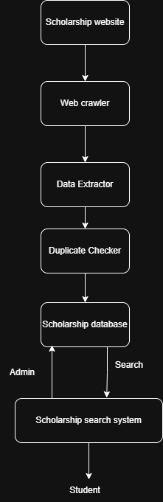

2.2 Main components:
- Scholarship Websites; these are trusted external websites that provide scholarship information. They act as the source of data for the web crawler.
- Web Crawler; the Web Crawler automatically visits the predefined scholarship websites using seed URLs. It retrieves web pages and follows relevant links to collect scholarship information.
- Data Extractor; the Data Extractor processes the downloaded web pages and extracts only relevant scholarship information such as the scholarship name, eligibility, deadline, funding type, and application link.
- Duplicate Checker; the Duplicate Checker compares newly extracted scholarship records with existing records in the database to prevent duplicate indexing.
- Scholarship Database; the database stores all validated scholarship information collected by the crawler. It acts as the central repository from which users retrieve scholarship information.

- Scholarship Search System; this component provides a user interface through which students search and view scholarship opportunities based on different criteria such as country, field of study or funding type.
- Administrator; the administrator manages the system by monitoring crawler activities, maintaining the database and ensuring the accuracy and freshness of the stored information.
2.3 Component Interaction
The system begins by crawling trusted scholarship websites using predefined seed URLs. The Web Crawler retrieves web pages, after which the Data Extractor identifies relevant scholarship information. The Duplicate Checker verifies whether the information already exists in the database before storing it. Students search the stored scholarship information through the Scholarship Search System, while the administrator monitors and manages the crawling process to ensure that the system operates efficiently.

3. Technical Requirement
3.1 User Roles
User role | Responsibilities
Student | Search scholarships, filter results, view scholarship details, access application links
Administrator | Manage crawler, manage seed URLs, monitor crawling, maintain database, remove duplicate records

3.2 Functional Requirements
ID | Functional Requirement
FR1 | Search scholarships
FR2 | Filter scholarship results
FR3 | View scholarship details
FR4 | Crawl scholarship websites
FR5 | Extract scholarship information
FR6 | Detect duplicate records
FR7 | Store scholarship information
FR8 | Manage seed URLs
FR9 | Monitor crawler
FR10 | Manage scholarship database

4. Non Functional Requirements
Category | Requirement
Performance | The system shall provide fast and efficient search functionality.
Reliability | The system should operate consistently with minimal downtime.
Availability | The system should be available whenever users need to access scholarship information.
Security | The system should protect both user information and stored scholarship data.
Usability | The system should be simple and easy to use.
Scalability | The system should accommodate future growth.
Maintainability | The system should be easy to maintain and update.
Compatibility | The system should function across different devices and web browsers.

5. System Architecture
5.1 Architectural Style
The Scholarship Finder Web Crawler and Search Engine follows a Layered Architecture where responsibilities are divided into different layers. Each layer performs a specific function and communicates only with adjacent layers. This approach improves maintainability, scalability, and modularity by separating the presentation logic, business logic, data processing and data storage.
The architecture consists of four main layers: Presentation Layer, Business Logic Layer, Crawling Layer and Data Layer. The Presentation Layer provides interfaces for students and administrators to interact with the system. Requests from users are processed by the Business Logic Layer, which validates inputs and coordinates system operations. The Crawling Layer retrieves scholarship information from trusted websites, extracts relevant details, and removes duplicate records before storing them. Finally, the Data Layer stores all scholarship records, user information, crawl logs and system configuration data.

Data flow diagram
The Data Flow Diagram illustrates how scholarship information moves through the system. The Web Crawler retrieves scholarship pages from trusted websites and forwards them to the Data Extraction process. Extracted information is checked for duplicates before being stored in the Scholarship Database. Students submit search requests to the Search Process, which retrieves matching scholarship records from the database and returns the results. Administrators manage the crawler and maintain the seed URLs used for crawling.
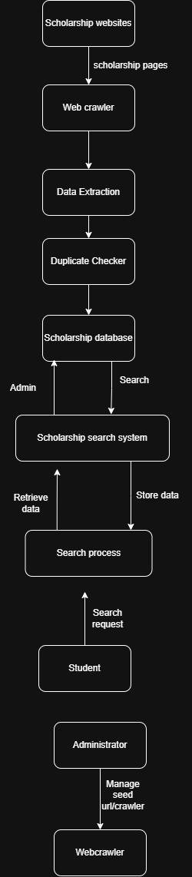

6. Detailed design
6.1 Data design
Data model: The system stores scholarship information in a relational database. The main entities include Scholarships, Administrators, Seed URLs, and Crawl Logs. These entities are related to support crawling, storage, searching, and administration of scholarship information.
Entity | Key Attributes
Scholarship | ScholarshipID (PK), Title, Country, Deadline, FundingType, Eligibility, ApplicationLink
Administrator | AdminID (PK), Username, Password
Seed URL | URLID (PK), URL, Status
Crawl log | LogID (PK), CrawlDate, Status

GitHub Repositoryhttps://github.com/Wins-let/Scholarship---Finder---Web---crawler;%20https:/github.com/Wins-let/Scholarship---Finder---Web---crawler

6.2 Interface Design
The primary interface is a single search page: a keyword input, a set of filter controls (country, field of study, degree level, deadline range) and a results list showing title, provider, deadline (with urgency highlighting) and a link to the source. A detail view expands a single scholarship to show full eligibility text.

Wireframe of the search page:

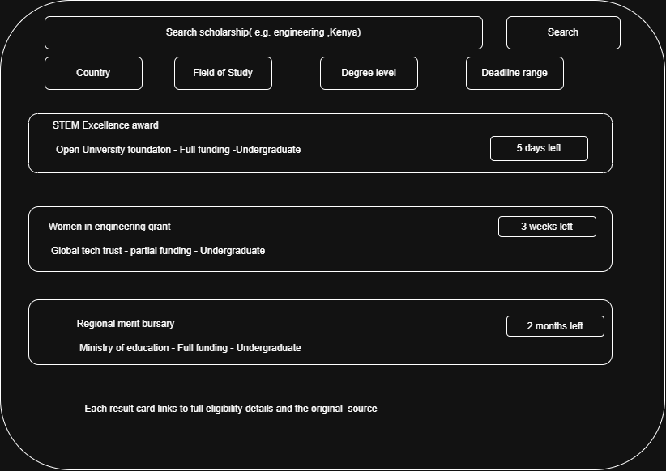

7. Security
The following security requirements shall be implemented to protect the system, users, and external scholarship websites:
- The crawler shall identify itself using a clear and descriptive User Agent string so that website administrators can recognize the source of requests.
- The crawler shall check and comply with robots.txt directives before accessing any web pages on a target website.
- The crawler shall implement rate limiting for each domain to avoid overloading scholarship websites and to ensure ethical web crawling practices.
- The system shall validate and sanitize all user search queries and administrator inputs before processing them.
- Administrator passwords shall be securely encrypted before being stored in the database.
- Access to the administration dashboard shall be restricted to authorized administrators through authentication and role-based access control.
- Student users shall only have permission to search and view scholarship information and shall not be allowed to modify system data.
- The system shall use HTTPS to secure communication between users and the web application.
- The scholarship database shall only be accessible by authorized system components and administrators.
- Regular database backups shall be performed to prevent data loss and support system recovery in case of failure.

8. Testing
The following testing activities will be carried out to verify the functionality, performance, and reliability of the Scholarship Finder Web Crawler and Search Engine.
Test type | Focus
Unit test | Test individual system components such as the Web Crawler, Data Extractor, Duplicate Checker, and Search Service independently to verify that each performs its intended function correctly.
Integration test | Test the interaction between the Web Crawler, Data Extractor, Database, and Search Service to ensure data flows correctly through the entire system.
Regression test | Re-run previous tests after system updates or modifications to ensure existing functionality, such as crawling, searching, and duplicate detection, continues to work correctly
Search functionality tests | Verify that search queries return accurate scholarship results and that filters such as country, funding type, field of study, and deadline produce the expected output.
Load and performance test | Measure the system's ability to handle multiple users performing scholarship searches simultaneously while maintaining acceptable response times.
Security test | Verify administrator authentication, access control, input validation, and protection against unauthorized access to the system and database.
Usability test | Evaluate whether students and administrators can navigate the system easily, perform searches efficiently, and complete tasks without confusion.

9. Deployment
For the scope of this project, deployment shall be kept simple. The Web Crawler shall run as a scheduled task (e.g., using a cron job or task scheduler) to periodically crawl predefined scholarship websites and update the scholarship database. The system database shall be hosted on a PostgreSQL or MySQL database server, while the Scholarship Search API and web interface shall be deployed as a lightweight web application (e.g., containerized using Docker or deployed on platforms such as Render or Railway for demonstration purposes). System configuration, including seed URLs, crawler rate limits, database credentials, and application settings, shall be stored in external configuration files or environment variables rather than being hard-coded into the application.
10. Maintenance
To ensure the continued reliability and effectiveness of the Scholarship Finder Web Crawler and Search Engine, the following maintenance activities shall be carried out:
- Monitoring: Crawl success and failure rates shall be logged for each scholarship website to quickly identify failures caused by website structure changes or connection issues.
- Updates: New scholarship websites shall be added by creating new Seed URL records. Where a website has a different page structure, a new data extraction rule shall be implemented without affecting existing extraction components.
- Support: The system shall provide an administrator dashboard that displays recent crawl failures, duplicate detection reports, and system logs to simplify troubleshooting and maintenance.
- Data Hygiene: Scholarships whose application deadlines have passed shall be automatically archived rather than permanently deleted, preserving historical records for future reference, reporting, and trend analysis.

11. Appendices
Glossary
Term | Definition
Web crawler | A software program that automatically visits websites and collects scholarship information.
Seed URL | The initial web address used by the crawler to begin collecting scholarship data.
Data Extraction | The process of identifying and retrieving relevant scholarship information from web pages
Duplicate Detection | The process of identifying and preventing duplicate scholarship records from being stored.
Search API | The application component that processes search requests and returns scholarship results.
User Agent | An identifier sent by the crawler to websites indicating the source of the request.
Robots.txt | A file published by websites that specifies which pages web crawlers are allowed to access.

Acronyms

Acronym | Meaning
SSD | System specification document
RCA | Root Cause Analysis
DFD | Data flow diagram
API | Application Program Interface
MoSCoW | Must have, Should have, Could have, Won't have (prioritization method)

